Thank you for joining us as we
Worship our Lord
December 19, 2021
10:15am Service

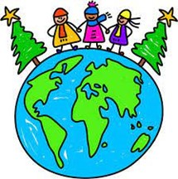

Mount Olive Lutheran Church
6965 Chestnut Ridge Road, Lockport, New York
Contact us: (716) 434-8500 or office@mtolivelockport.org
Website: mtolivelockport.org
Facebook: Mount Olive Lutheran Church

STEWARSHIP NOTE. . .
We give gifts at Christmastime because God gave The Greatest Gift. God acts, we imitate, and grow in His image.

Sunday, December 19, 2021
Blended Non Communion Service
Youth Christmas Program
“Christmas Around the World”

Divine Service II Lutheran Worship

Pre-Service Music

OPENING HYMM
“Oh, Come, All Ye Faithful”

Oh, Come, All Ye Faithful
Joyful and triumphant,
Oh come ye, oh, come ye to Bethlehem;
Come and behold Him,
Born the King of angels;
Oh, come let us adore Him,
Oh come, let us adore Him,
Oh, come let us adore Him,
Christ the Lord.

Highest, most holy,
Light of light eternal
Born of a virgin, a mortal He comes.
Son of the Father, Now in flesh appearing;
Oh, come let us adore Him,
Oh come, let us adore Him,
Oh, come let us adore Him,
Christ the Lord.

Yea, Lord, we greet Thee,
Born this happy morning,
Jesus, to thee by glory giv’n.
Word of the Father, now in flesh appearing;
Oh, come let us adore Him,
Oh come, let us adore Him,
Oh, come let us adore Him,
Christ the Lord.
SUNDAY SCHOOL WELCOME

PART 1: LIGHT OF THE WORLD

Reader 1: At this time of year, all kinds of special lights are glowing all around the world for Jesus. We string sparkling lights on Christmas trees in our houses and yards. In Germany like here in our church, candles are lit on Advent wreaths. A German pastor designed the first advent wreath in the 1830’s to help children in his mission school count the days until Christmas.
Reader 2: In Brazil, huge Christmas trees are decorated with electric lights that are visible everywhere against the night sky. In Argentina, families float “globos” or paper balloons lit from inside, high into the air. Fireworks are set off in Latin American countries to celebrate the majesty of Christmas with a show of both light and sound. These lights remind us of God’s promise of a Savior given in the book of Isaiah.

Reader 3: Scripture Reading Isaiah 9: 2-3, 6
“The people walking in darkness have seen a great light; on those living in the land of the shadow of death, a light has dawned. You have enlarged the nation and increased their joy: they rejoice before you as people rejoice at the harvest, as men rejoice when dividing the plunder. For to us a child is born, to us a son is given, and the government will be on his shoulders. And he will be called Wonderful Counselor, Mighty God, Everlasting Father, Prince of Peace.”

Reader 4: In China, not as many people know about Jesus and Christmas is not a public holiday. This hasn’t stopped Christians in this country from filling churches on Christmas eve. Chinese Christians have “trees of light” decorated with paper chains, paper flowers, and paper lanterns.
Reader 5: In Ukraine, families light a candle in a loaf of bread and place it in the middle of their Christmas eve table. Families in the Ukraine scatter stalks of wheat on their tables as a way to remember the manger where Jesus lay.
Reader 1: In Mexico, on Christmas Eve, groups of people wander from house to house pretending to look for a warm place to stay, like Mary and Joseph did when they came to Bethlehem. Everywhere people are turned away until they find the nativity scene.

Reader 6: Scripture Reading Luke 2: 1-7
“In those days Caesar Augustus issued a decree that a census should be taken of the entire Roman world. And everyone went to his own town to register. So Joseph also went up from the town of Nazareth in Galilee to Judea, to Bethlehem the town of David, because he belonged to the house and line of David. He went there to register with Mary, who was pledged to be married to him and was expecting a child. While they were there, the time came for the baby to be born, and she gave birth to her firstborn, a son. She wrapped him in cloths and placed him in a manger, because there was no room for them in the inn.”

Reader 2: So many different lights remind us that Jesus was sent to be the Light of the World. These lights help us remember that God loves and cares for each and every one of us. We can share His light by showing kindness and love to others in all that we do. His Light is meant to be shared.

Sunday School Children: This Little Gospel Light of Mine

PART 2: SING TO THE LORD A NEW SONG

Reader 7: One of the ways that we show and share our joy in Jesus is through the singing of Christmas carols. In Italy in the week before Christmas, children dress up as shepherds wearing sandals and shepherd’s hats. The children then go from house to house singing and playing flutes.
Reader 8: In Romania, for many years the government would not let Christians celebrate Christmas. But now Christians in Romania walk through town singing Christmas carols behind a big wooden star covered with metal foil with a picture of the Nativity pasted in the middle.
Reader 7: In Australia, Christmas comes in the middle of the summer, so it looks more like a July 4th celebration. Australians gather outside for Christmas Eve services, like in the city of Melbourne where thousands gather at a placed called the Music Bowl.
Reader 8: Music is also celebrated in Wales, one of the four countries that makes up the United Kingdom. Welsh people often sing Christmas carols to the sound of a harp. A contest is held each year in Wales to see who can write the best new Christmas carol.
Reader 7: In Haiti, many people stay up all night going to midnight service, launching fireworks, and singing Christmas carols. They celebrate with a big feast that lasts until the sun comes up on Christmas day. All over the world, people’s hearts are bursting with joy as we await Christmas, just as angels sang with joy on the very first Christmas eve when Jesus was born.

Readers 9 and 10: Scripture Reading: Luke 2: 8-20
And there were shepherds living out in the fields nearby, keeping watch over their flocks at night. An angel of the Lord appeared to them, and the glory of the Lord shone around them, and they were terrified.
But the angel said to them, “Do not be afraid. I bring you good news of great joy that will be for all the people. Today in the town of David a Savior has been born to you; he is Christ the Lord. This will be a sign to you: You will find a baby wrapped in cloths and lying in a manger.”
Suddenly a great company of the heavenly host appeared with the angel, praising God and saying, “Glory to God in the highest, and on earth peace to men on who his favor rests. When the angels had left them and gone into heaven, the shepherds said to one another, “Let’s go to Bethlehem and see this thing that has happened, which the Lord has told us about.”
So they hurried off and found Mary and Joseph, and the baby, who was lying in the manger. When they had seen him, they spread the word about this child, and all who heard it were amazed at what the shepherds said to them.
But Mary treasured up all these things and pondered them in her heart. The shepherds returned, glorifying and praising God for all the things they had heard and seen, which were just as they had been told.

Reader 10: Thousands of years later, we still sing with joy around the world. People around the world may be singing different carols or in different languages, but just like us, they are singing with joy for the birth of Jesus our Savior.

Sunday School Children:

“Christ is Born Today”
(Sung to tune of Jingle Bells)

Verse 1 (sung by children)
Many years ago, in a stable far away
Christ the Lord was born, what a joyful day
Singing filled the air, glory shone around,
Shepherds on the hillside were astonished by the sound. Oh!
Chorus:
Have no fear! Have you heard?
Christ is born today.
Go and see him lying there
In a manger filled with hay. Hey!
Then the sky came alive, angels everywhere
Singing hymns of joyful praise
to God who sent them there.
Verse 2 (congregation joins in)
On to Bethlehem, a most exciting way.
Shepherds went to see, Christ the Lord that day.
When they saw him there, they were filled with joy
On their knees they worshipped him God's special baby boy. Oh!
Chorus
PART 3: THE STAR OF CHRISTMAS

Reader 11: Even though people had been waiting and waiting for a Savior for thousands of years, when Jesus came, many people missed recognizing him because he came in such an unexpected way. He wasn’t the powerful king they expected, but rather a poor carpenter’s son. Through the eyes of faith, the Wise Men, among others, did recognize Jesus as the Savior.
Across India, as Christmas approaches, Christian families hang handmade star-shaped lanterns. These beautiful pieces represent shining God’s light to the world. These stars, which remind us of the starlight that led the wise men from the east to Jesus, are a way for the Christian minority in India to witness their faith among their neighbors.
In Spain, Christmas preparations begin on December 8th with decorating of Christmas trees. Gifts are not exchanged until Epiphany on January 6th to recognize the timing of the Wise Men bringing gifts to Jesus.

Readers 12 and 13: Scripture Reading: Matthew 2: 1 - 12
After Jesus was born in Bethlehem in Judea, during the time of King Herod, Magi from the east came to Jerusalem and asked, “Where is the one who has been born king of the Jews? We saw his star in the east and have come to worship him.” When King Herod heard this he was disturbed, and all Jerusalem with him.
When he had called together all the people’s chief priests and teachers of the law, he asked them where the Christ was to be born. “In Bethlehem in Judea,” they replied, “for this is what the prophet has written: But you, Bethlehem, in the land of Judah, are by no means least among the rulers of Judah; for out of you will come a ruler who will be the shepherd of my people Israel.”
Then Herod called the Magi secretly and found out from them the exact time the star had appeared. He sent them to Bethlehem and said, “Go and make a careful search for the child. As soon as you find him, report to me, so that I too may go and worship him.” After they had heard the king, they went on their way, and the star they had seen in the east went ahead of them until it stopped over the place where the child was.
When they saw the star, they were overjoyed. On coming to the house, they saw the child with his mother Mary, and they bowed down and worshiped him. Then they opened their treasures and presented him with gifts of gold and of incense and of myrrh. And having been warned in a dream not to go back to Herod, they returned to their country by another route.

Congregation Sings:

“We Three Kings”

We three kings of Orient are,
Bearing gifts we traverse afar.
Field and fountain, moor and mountain,
Following yonder star.
O, star of wonder, star of night.
Star with royal beauty bright.
Westward leading, still proceeding;
Guide us to thy perfect light.

Glorious, now behold Him arise;
King and God and Sacrifice.
Alleluia, alleluia, Heaven to earth replies.
O, star of wonder, star of night.
Star with royal beauty bright.
Westward leading, still proceeding;
Guide us to thy perfect light.

Sunday School Processional to the Manger (Special music)

PART 4: THE GIFT OF CHRISTMAS
Reader 14: Across the world this Christmas, people will be sharing gifts with one another. Whether we are looking in stockings or finding gifts in wooden shoes, each and every gift is a reminder of the greatest present God gave to the entire world.
The true gift of Christmas isn’t wrapped with a bow.
It has nothing to do with holly or snow.
The true gift of Christmas, my dear friends, you see,
Isn’t a package placed under a tree.

The true gift of Christmas came from heaven one night,
Wrapped in years of love and a brilliant white light.
As showers of praises spilled over the earth,
Angels joined shepherds to shout out His birth.

The true gift of Christmas came down from above
To show us our Father’s unconditional love.
His teaching and promise are ours to receive,
With a childlike wonder and a heart that believes.

The true gift of Christmas? A babe in the hay.
A chorus of angels. A debt we can’t pay.
A heavenly father. The gift of His son.
Life everlasting. Eternity won.

Sunday School Children:

“Go Tell It on the Mountain”

Refrain:
Go, tell it on the mountain, Over the hills, and ev’rywhere;
Go, tell it on the mountain, That Jesus Christ is born.

Verse 1 (Sunday School Children)
While shepherds kept their watching, O’er silent flocks by night,
Behold throughout the heavens, There shone a holy light. Refrain.

Verse 2 (Congregation Joins In)
The shepherds feared and trembled, When lo, above the earth
Rang out the angel chorus, That hailed our Savior’s birth. Refrain.

CHILDRENS MESSAGE

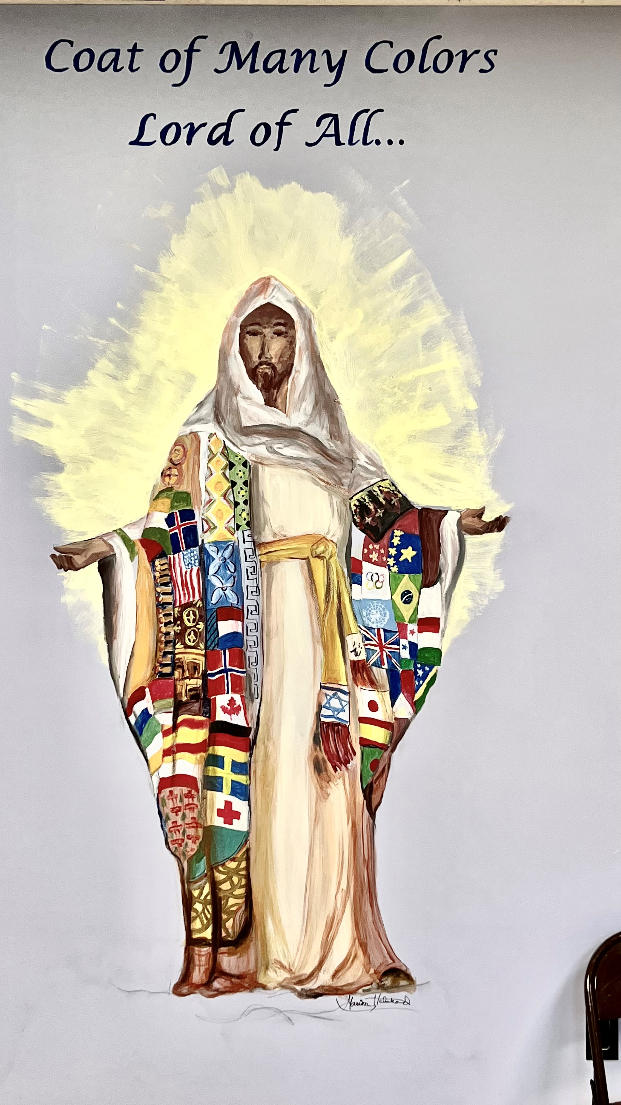

PRAYERS OF THE CHURCH (Responsive)
When there is no communion, Pastor will give prayers as guided by the Holy Spirit.
Pastor: Lord in Your Mercy
People: Hear Our Prayer

LORD’S PRAYER Matthew 6:9–13
Taught by our Lord and trusting in His promises, we are bold to pray:
Our Father who art in heaven,
hallowed be Thy name,
Thy kingdom come,
Thy will be done
on earth as it is in heaven;
give us this day our daily bread;
and forgive us our trespasses
as we forgive those who trespass against us;
and lead us not into temptation,
but deliver us from evil.
For Thine is the kingdom
and the power and the glory
forever and ever. Amen.

FIRST FRUITS OFFERING

BENEDICTION
Pastor: The Lord bless you and keep you.
The Lord make His face shine on you and be gracious to you.
The Lord look upon you with favor and † give you peace.
People: Amen.

Congregation and Sunday School

“Joy to the World”

Joy to the World! The Lord is come.
Let earth receive her King.
Let every heart
Prepare Him room
And heaven and nature sing,
And heaven and nature sing
And heaven and heaven and nature sing.

He rules the world with truth and grace,
And makes the nations prove
The glories of His righteousness
And wonders of His love;
And wonders of His love.
And wonders, wonders of His love.

From our Sunday School teachers,
thank you for coming today
and Merry Christmas!

Readers from Confirmand and High School Classes:

- Jackson Kobrin
- Tyler Tracz
- Elliot Moran
- Robert Clark
- Jacob Schulz
- Christopher Klupp
- Claire Cavanagh
- Marah Kobrin
- Hannah Schulz
- Dominic Faraci
- Jason Zang
- Sarah Tracz
- Olivia Hasley
- Leah Cavanagh

Preschool through 5th Grade Students:

Emma Andrews Maisie Coldicott
Thomas Andrews Luke Haseley
Louise Carver Alice Stefanko
Henry Cavanagh Anna Odrobina
Ellenora Clark Camellia Tapp
Aria Coldicott LilyAnne Tapp

